Name: Digvijay Vikas Sawant
PRN: 260240125023
Form no: 251100327
Q1. Use `pwd`, `ls`, `cd` to explore the file system and display current location.
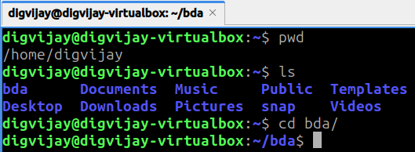
Q2. Create directories `lab1/lab2/lab3` using one command.
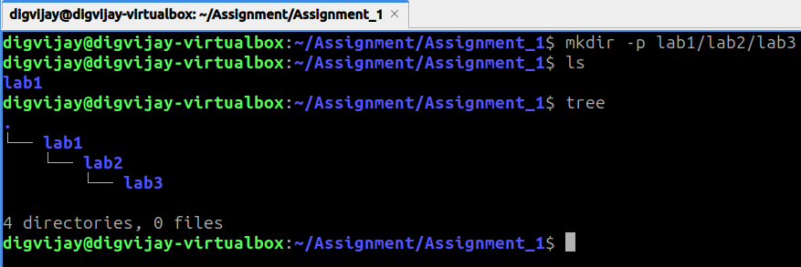
Q3. Create 10 files (`file1` to `file10`) inside `lab3` using one command.
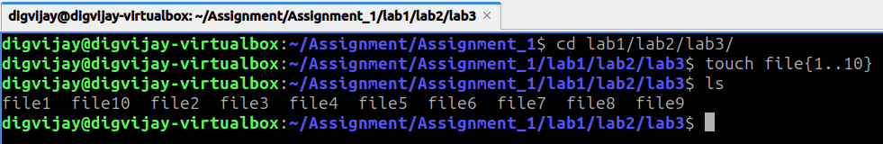
Q4. Display who is logged in with `who`, and the current user with `whoami`.
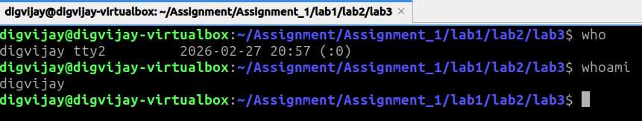

Q6 Create 50 files `data1` to `data50` inside a directory with a single command.
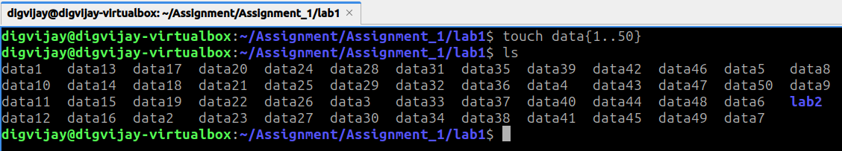
Q7. Copy all `.txt` files from one folder to another using wildcards.
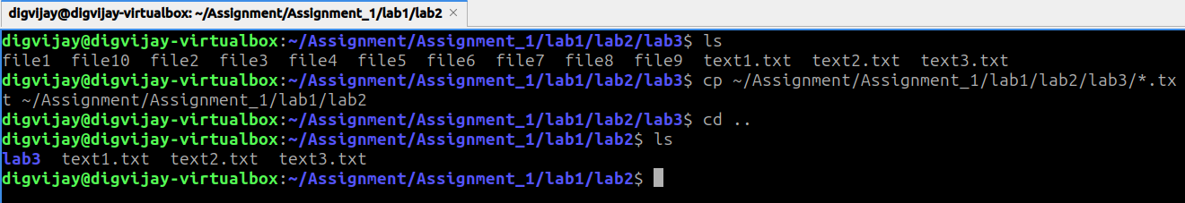
Q8. Use `cat`, `less`, `head`, `tail` to view file contents.
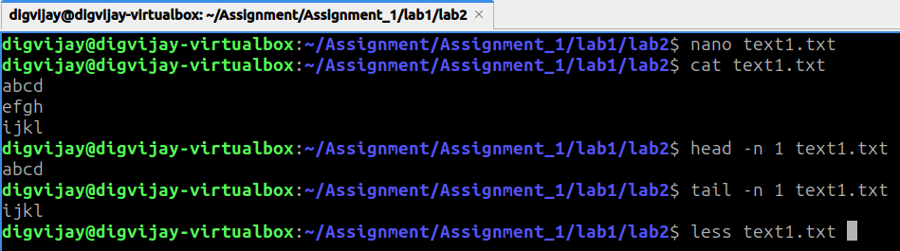
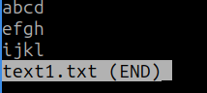
Q10. Redirect the output of `ls -l` to a file and append the date to it.
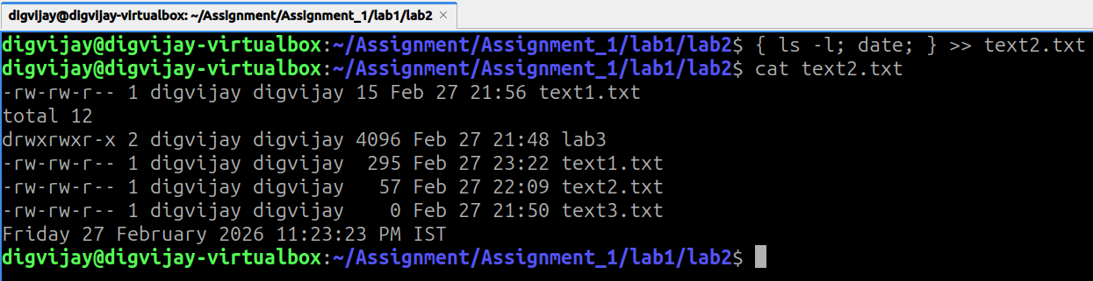

Name: Digvijay Vikas Sawant
PRN: 260240125023
1. Create a directory named `workspace` in your home folder.
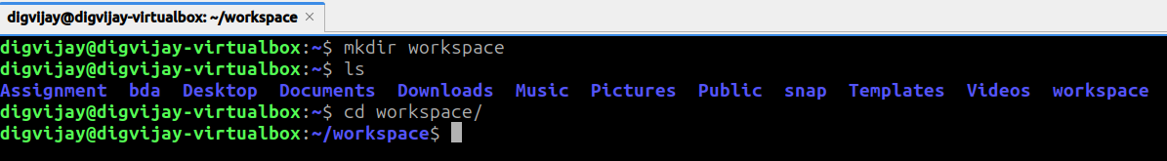
2. Inside `workspace`, create two subdirectories named `source` and `backup`.
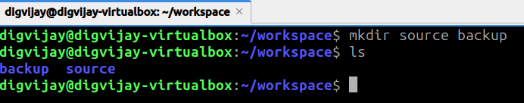
3. Create three empty files in `source` named `alpha.txt`, `beta.txt`, and `gamma.txt`.
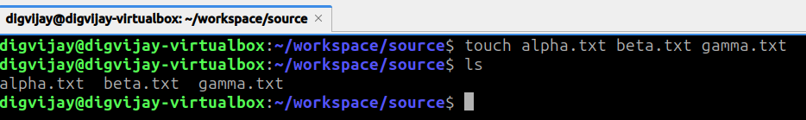
4. Rename `alpha.txt` to `delta.txt`.
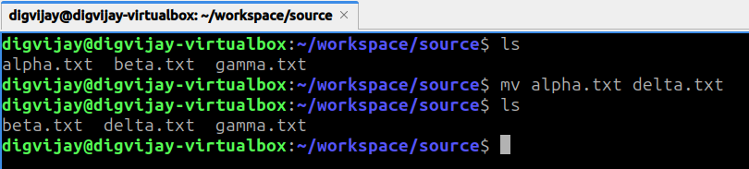
5. Move `delta.txt` from the `source` directory to the `backup` directory.
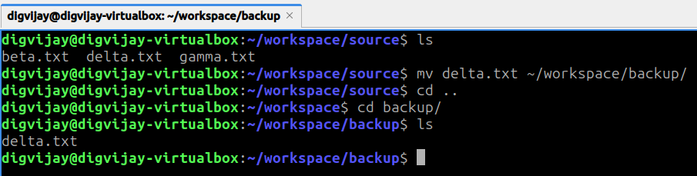

6. Create a new user named `intern`.
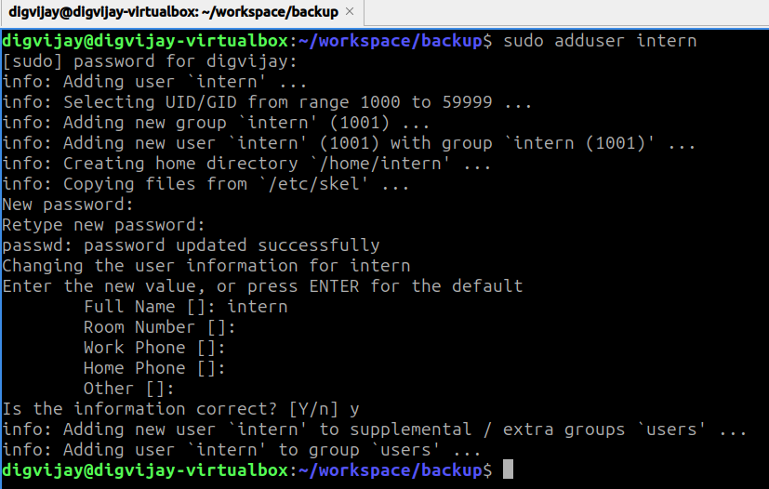
7. Create a new group named `training`.
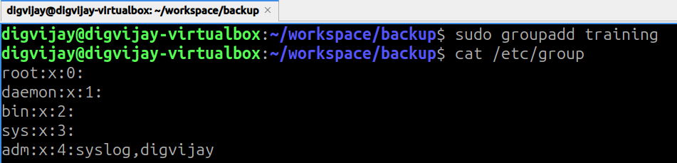
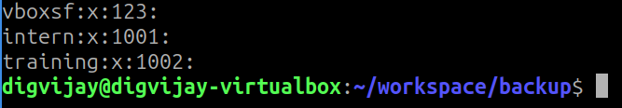
8. Add the user `intern` to the `training` group.
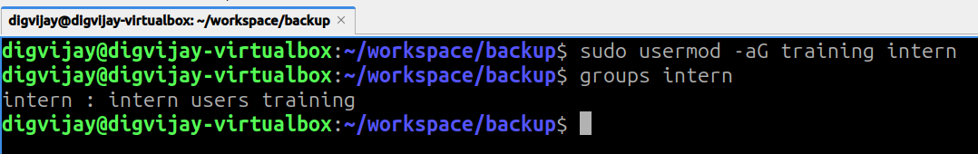

9. Change the password for the user `intern`.
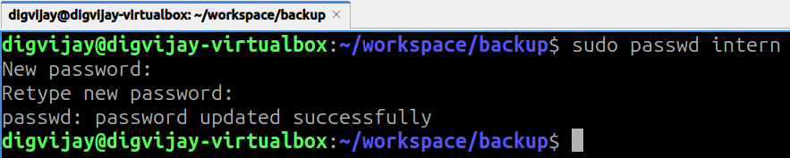
10. Create a file named `private.txt` and set permissions so only the owner can read and write to it ($rw-------$).
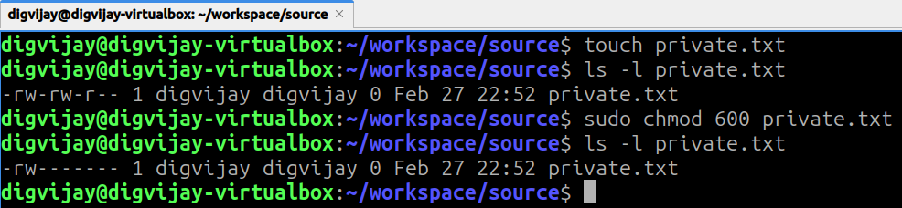
11. Create a file named `public.txt` and set permissions so everyone can read it, but only the owner can write to it ($rw-r--r--$).
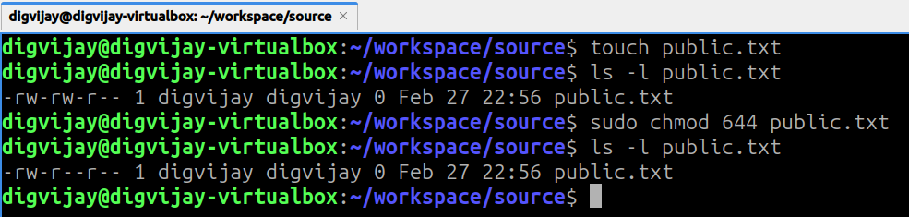
12. Create a file named `script.sh` and give it execute permissions for the owner, group, and others ($rwxr-xr-x$).
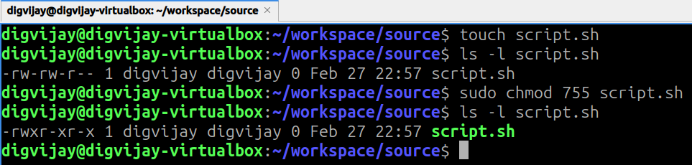

13. Change the owner of `backup/delta.txt` to the user `intern`.
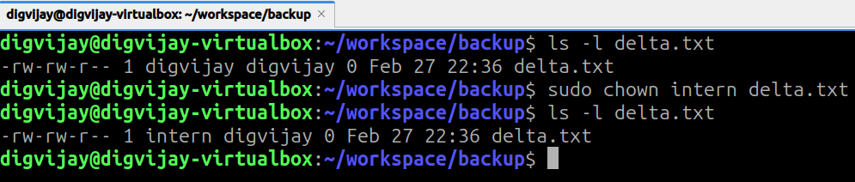
14. Change the group ownership of the `workspace` directory to `training`.
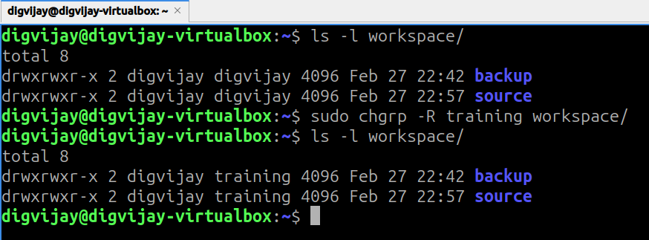
15. Delete the file `source/beta.txt`.
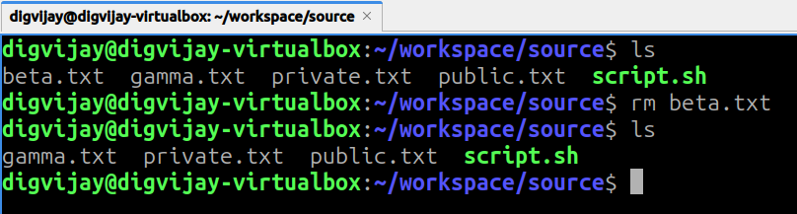
16. Delete the `source` directory and all files remaining inside it using a single command.
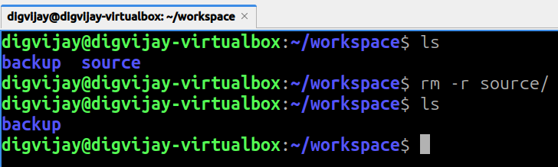

17. List all files in the `/etc` directory and save the output to a file named `etc_list.txt`.
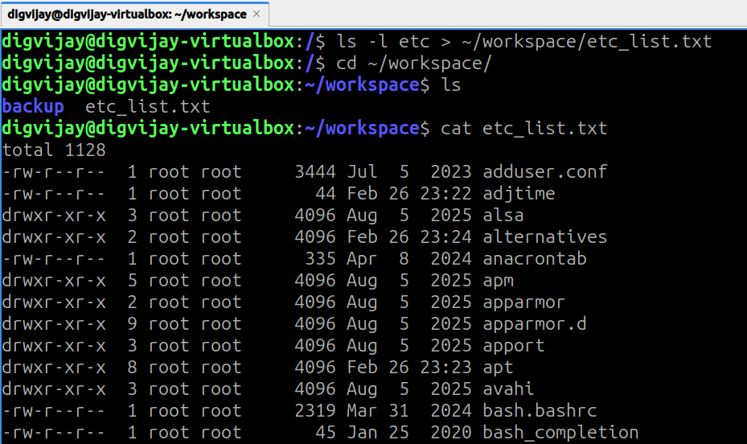
18. Use a command to see the last 10 lines of the `/etc/passwd` file.
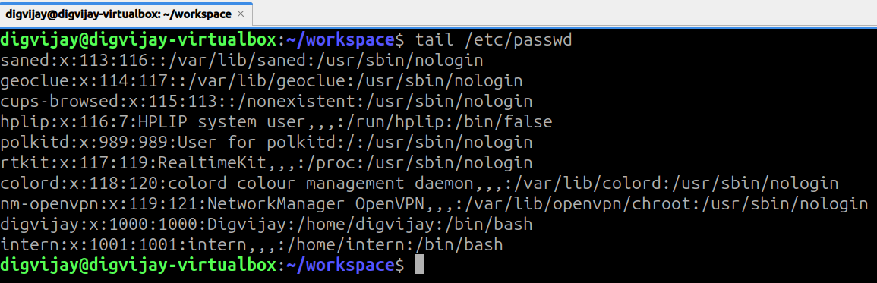
19. Use a command to see the first 5 lines of the `/etc/group` file.
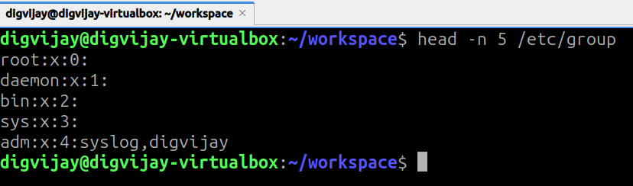

20. Search for the string "nologin" inside the `/etc/passwd` file and count how many lines contain it.
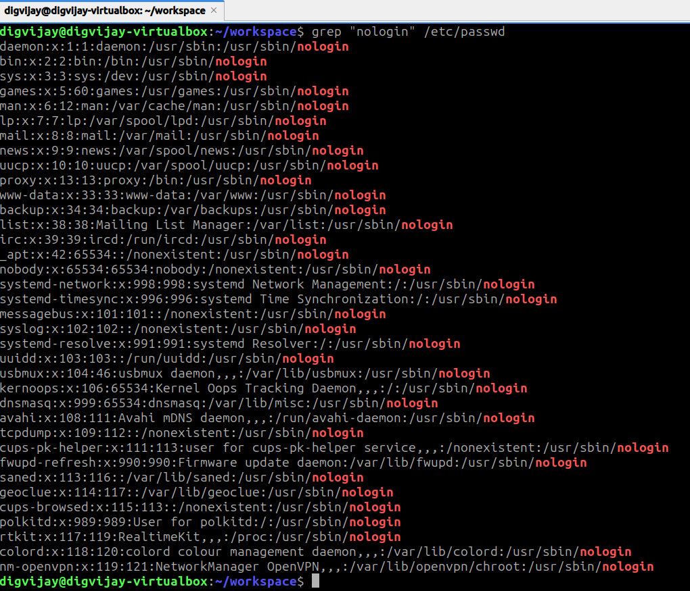
21. Find all files in the `/var` directory that end with the extension `.log`.
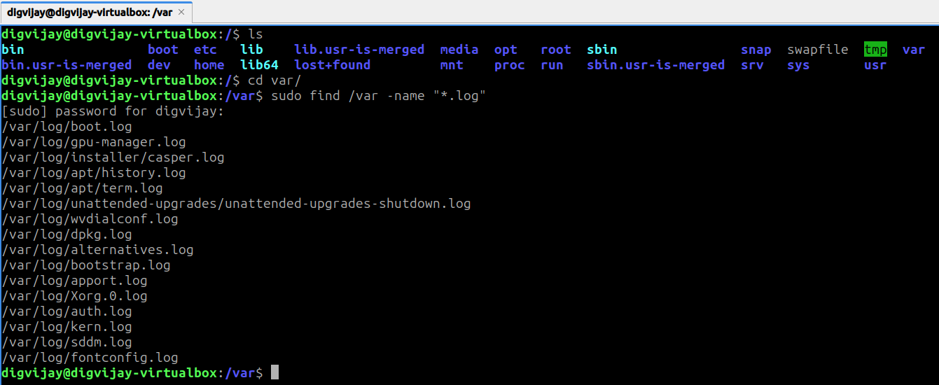

22. Create a symbolic link in your home directory named `link_to_delta` that points to `workspace/backup/delta.txt`.
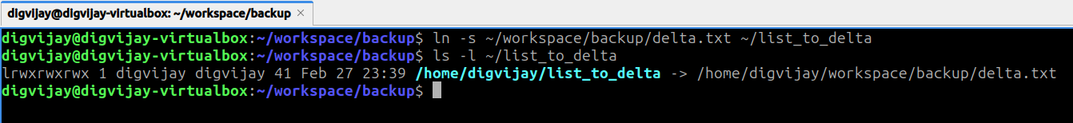
23. Create a hidden file named `.secret` in your home directory.
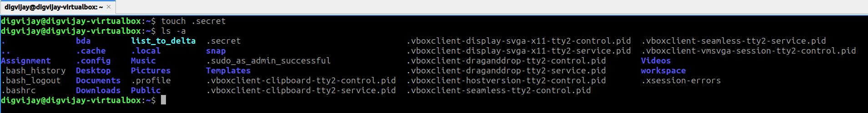
24. List all files in your home directory, including hidden files, in a long format ($ls -la$).
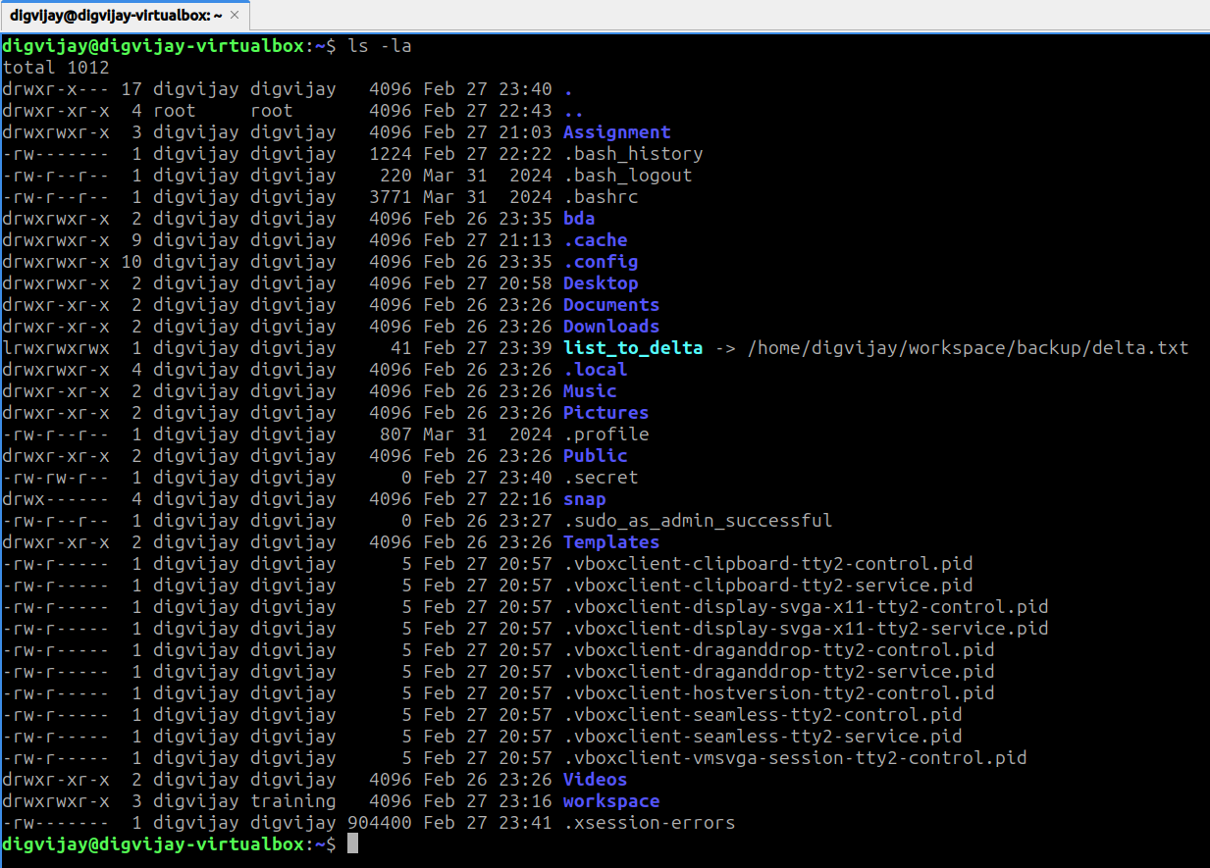

25. Display the current system date and time and append it to a file named `timestamp.txt`.
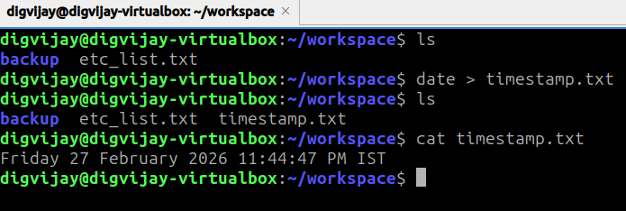
26. Display the name of the current logged-in user.
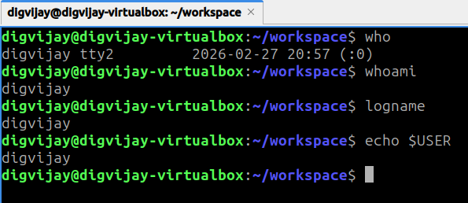
27. Display the path of your current working directory.
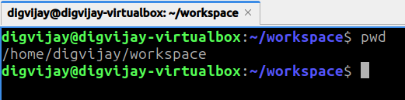

28. Use the `df` command to check disk space in human-readable format and save it to `disk_usage.txt`.
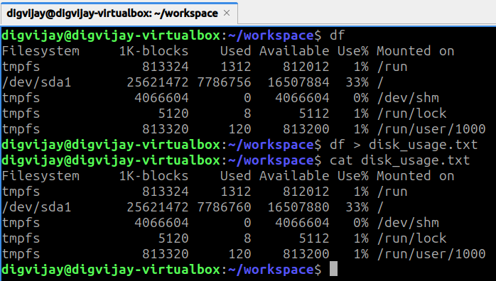
29. Use the `du` command to check the size of the `workspace` directory.
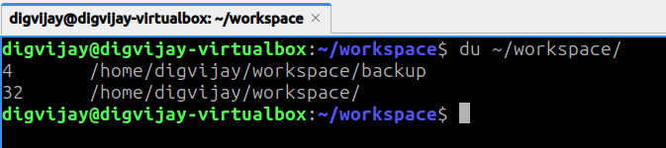
30. Identify your system's IP address using the command line.
